*John J Huang, MD* President of CTUF was formerly at Residency Program Director and Director of Uveitis Yale Eye Center. Graduate of Johns Hopkins School of Medicine, he completed his residency at NYU Medical center/Manhattan Eye, Ear Throat Hospital, with fellowship at Wilmer Eye Institute at Johns Hopkins and Massachusetts Eye & Ear Infirmary at Harvard.

*Paul A. Gaudio, MD* Vice President of CTUF originally from the state of Connecticut completed medical school at Albert Einstein College of Medicine, Residency at Yale University, and fellowship at Proctor Foundation at University of California at San Francisco.

Both Drs Huang and Gaudio are fellowship trained uveitis specialist who are dedicated to caring for uveitis patients, advance the research for the treatment of uveitis, teaching new generations of residents and fellows, working with other uveitis specialist to improve access, and collaborating with other specialist in medicine to reduce morbidity in uveitis patients.



Contributions to the

*Connecticut Uveitis Foundation*

can be mailed in using this form

or on our website:

1043 Farmington Avenue

West Hartford, CT 06107

Phone: (860)561-8617

Fax: (860)561-8657

**Web:** [**www.uveitisct.org**](http://www.uveitisct.org)

______________________________________

Name

______________________________________

Billing address

_____________________________________

City, State, Zip

______________________________________

Phone

______________________________________

Email

Pledge of _____________________to be paid

____Now____Monthly____Quarterly____Yearly

____ Check ____Credit Card ____Other

______________________________________

Credit Card Number

______________________________________

Type(ie:Visa, MC) / Expiration Date

______________________________________

Authorized Signature Date

Please acknowledge the following people

________________________________________

________________________________________

* We wish to remain anonymous

*Please make checks payable to Ct Uveitis Foundation



# **Connecticut**

# **Uveitis**

# **Foundation**

Date of publication

## *Healing and knowledge*

how to customize this brochure

The **Connecticut Uveitis Foundation** was established in 2014 as an effort to foster patient education, research, knowledge exchange and training locally in this field.

The term **uveitis** refers to infections and inflammation of the eye. This group of diseases is a major cause of blindness in the United States and worldwide, despite being treatable in most cases. It is especially devastating since it afflicts children and young adult(s).

**CTUF** provide uveitis patients with information of the latest FDA approved treatments, off-label medical therapies, surgical options and current clinical trials for the treatment of uveitis. The foundation’s goal is also to support uveitis patients by improving access to the uveitis specialist to reduce the ocular morbidity associated with this condition.

For CTUF quarterly accounts,

please go to our website:

www.uveitisct.org

**Clinical Support & Training**

Nationwide and worldwide, there is a shortage of trained uveitis-trained specialists, nurses and ancillary personnel. CTUF offers supplementary funding for uveitis training to individuals with extraordinary potential as caregivers.

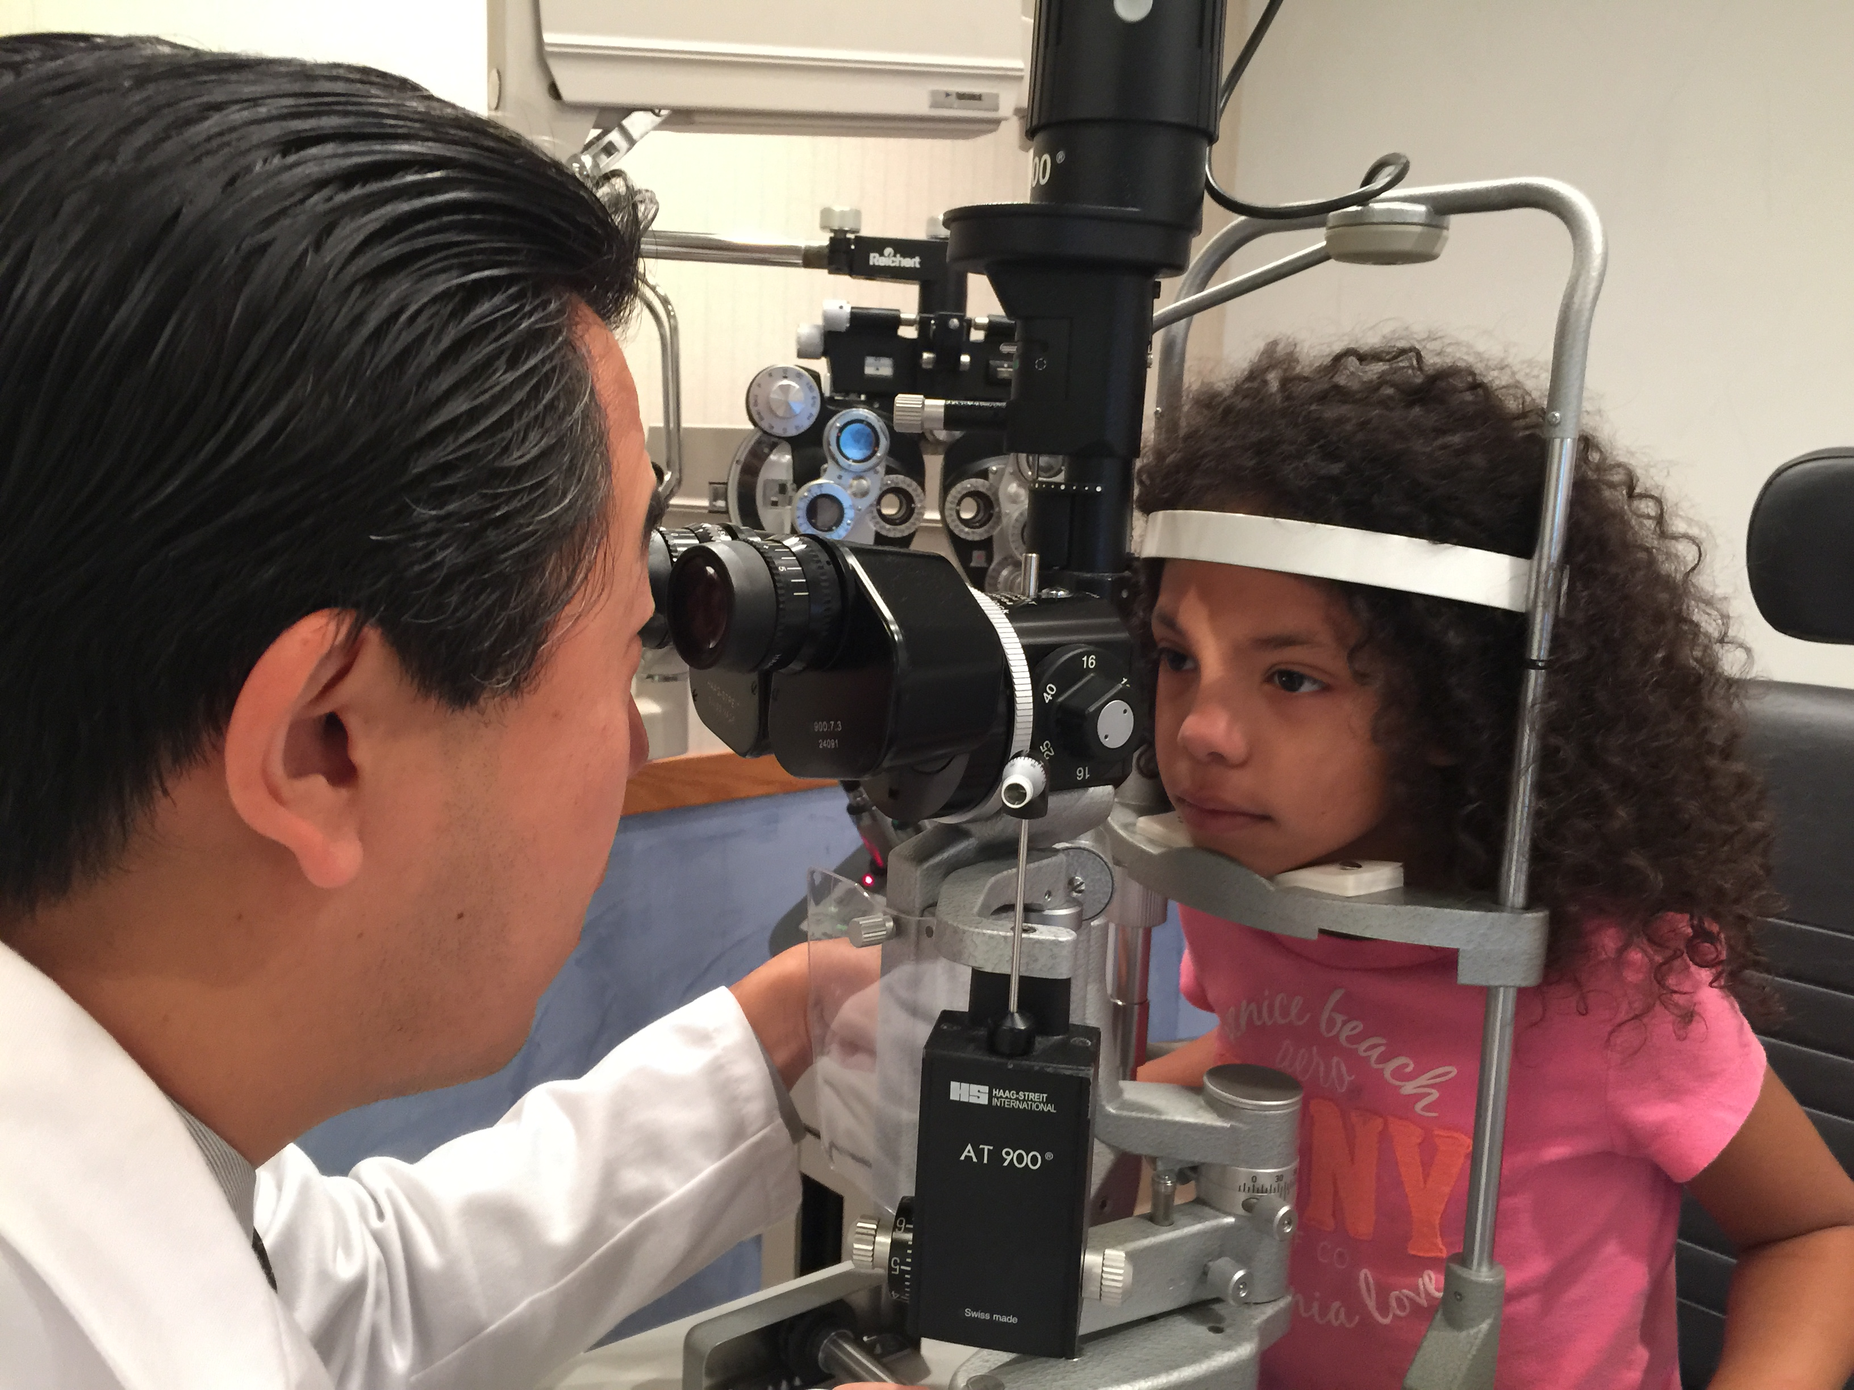

**Research**

CTUF believes that useful discoveries can arise from data generated locally in eye disease care and referral centers.

**Patient Education**

Though CTUF does not subsidize or conduct patient care, we provide patient education through methods such as discussion forums, patient clinical trials and information on latest treatments.

For a list of Connecticut uveitis specialists, please go to our website:

www.uveitisct.org

Connecticut Uveitis Foundation

1043 Farmington Avenue

West Hartford, CT 06107